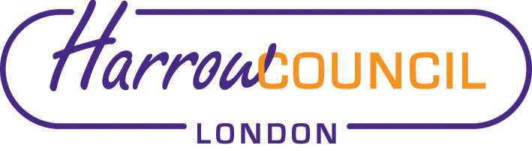
Harrow SACRE Meeting

Tuesday 15 October 2019 at 7.30 p.m.
To be held in Committee Rooms 1-2
Harrow Civic Centre

Enquiries & apologies to:
Vivian Wright, Clerk to SACRE
vmwright@waitrose.com

Adviser to SACRE: Lesley Prior

Agenda
- Welcome:

- Apologies for absence:

- Minutes of the last meeting on 27 June 2019: to agree the minutes as a true record.

- Matters arising from the minutes

- Monitoring of syllabus and websites: website reviews in light of new Ofsted
Inspections

- News from NASACRE

- Annual report 2018-19

- Determinations

- Marlborough Determination

- Collective Worship working group

- Dates for religious days of worship: to agree up-dated calendar

- LGBT and education

- SRE.

- News from Faith Groups relating to schools

- Any Other Business

- Future Dates
- Tuesday 10 December
- Tuesday 24 March

